Oura Ring 4 Review Sentiment Analysis

Fordham University Gabelli School of Business
Spring 2026 Natural Language Processing and Applications (BYGB-7977-003)
Christine Whelan, Madison Quattlander, Sofia Williner, Taylor King

Executive Summary
The wearable technology industry generates thousands of customer reviews as a natural byproduct of product launches. While retailers increasingly offer AI-generated review summaries and feature-level overviews, these tools are built for shoppers rather than product teams and do not provide the cross-platform, priority ranked, feature-level insights needed to guide product development decisions. This project addresses that gap by applying text analytics to 4,240 Oura Ring 4 reviews scraped from Best Buy, Amazon, and Target between October 2024 and March 20206, with the goal of translating unstructured customer feedback into actionable recommendations for the next-generation Oura Ring 5. This project approaches the analysis as if Oura Health had engaged our team as consultants to identify which features of the Oura Ring 4 should be improved, refined, or preserved in the development of the next-generation Oura Ring 5.
The analytical pipeline consisted of text preprocessing, TF-IDF feature representation, sentiment classification, topic modeling, and aspect-based sentiment analysis. Four classifiers were trained and evaluated, with class weighting applied to address the dataset’s imbalance toward positive reviews. While Linear SVM achieved the highest F1 score at 0.96, Logistic Regression was selected as the final model due to its comparable performance (F1=.95) and greater interpretability.
The results reveal that while overall sentiment toward the Oura Ring 4 is largely positive, meaningful variation exists at the feature level. Durability emerged as the most critical improvement area, indicating that customer expectations for product longevity are not being met. Battery life followed as a secondary concern. In contrast, sleep tracking, comfort, and app experience emerged as clear strengths with strong sentiment and high mention volume. These findings translate into a clear prioritization framework for the Oura Ring 5 and demonstrate how text analytics can serve as a scalable business decision support tool in the wearable technology market.

Business Goal Analysis:

Over the years, the wearable technology industry has experienced significant growth, with companies relying on customer feedback to improve product performance and overall user experience. An example of this includes Oura Health, a company that collects thousands of customer reviews across major retail platforms, including Amazon, Target, and Best Buy as a natural byproduct of launching their devices. In today's competitive technology landscape, these reviews are a key source of business intelligence, containing valuable insights into user satisfaction, product performance, and areas for improvement.
Nevertheless, companies often rely on manual review reading and basic rating systems to evaluate their customer feedback; and while star ratings provide a solid overview of satisfaction, these methods are neither scalable nor systematic at the volume that a product like the Oura Ring 4 generates across multiple retail channels. Therefore, this not only fails to capture detailed opinions about specific product features to make informed development decisions, but also its time-consuming, subjective, and not scalable.
In order to address this limitation, this project applies text analytics to address that gap. With over 4,240 Oura Ring 4 reviews scraped from Best Buy, Amazon, and Target, the goal is to systematically extract sentiment patterns from customer feedback in reviews. In this case, text analytics is a strong method for this task as it enables sentiment classification at scale, breaks down customer opinion by product feature, and identifies recurring themes through topic modeling; advantages that star rating reviews alone cannot provide. Moreover, analyzing reviews from various retailers deepens the scope of the dataset, strengthening overall analysis and conclusions.
Through this approach the project focuses on translating insights into actionable recommendations identifying potential improvements for wellness tracking in the next-generation Oura Ring 5. Overall, the project itself demonstrates how text analytics can be used as a business decision support tool by allowing companies to prioritize product improvements, customer satisfaction, and maintain a competitive advantage in the wearable technology market.

Dataset Description:

The dataset used in this project consists of 4,240 customer reviews of the Oura Ring 4 collected from multiple retail platforms including Best Buy, Amazon, and Target posted between October 2024 and March 2026. This broad range of dates helps identify different consumer experiences across the product’s lifespan after its release. The reviews were scraped from each retailer’s public product pages with both unstructured and structured data. The customer’s text being unstructured and the metadata as the star ratings, source platform, verified purchase status, helpful vote count, and review dates being structured.
Regarding the variation of reviews across each platform, the majority of reviews were sourced from Best Buy (3,557), while Amazon contributed with 488 and Target with 195. Of the 4,240 reviews, 3,947 were marked as verified purchases, that is around 93% of the dataset showcasing a high degree of credibility. Now, the rating distribution of the reviews is highly skewed towards positive feedback, with 3,061 were 5-star reviews (around 72% of the dataset). While 1- or 2-star reviews represent approximately 11%. This imbalance is important to highlight in the modeling phase in order to prevent the classifier from being biased and predict false positive sentiment.
Lastly, the raw dataset was stored in CSV format and contained one primary text field (the review body), serving as the input for all subsequent text analytics steps. Also, before modeling, the data was fully preprocessed to clean and standardize the text.

System Design:
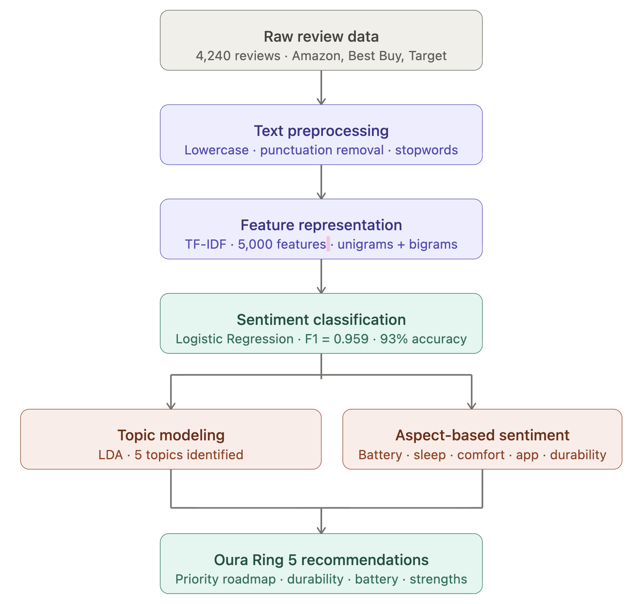
Figure 1: Oura Ring Flowchart
The system design for this project uses a multi-phase pipeline to convert unstructured, raw customer review text into structured sentiment insights and product recommendations. This means that each phase builds upon the previous one, moving from raw text cleaning through feature extraction, sentiment classification, and finally the analysis of customer opinions across each individual product feature.
The first stage, text preprocessing, focuses on preparing raw review data for analysis by removing noise and standardizing the text. This step ensures that inconsistencies such as formatting differences, irrelevant characters, and common non-informative words do not negatively impact downstream modeling. Special consideration is given to preserving negation words to maintain the integrity of sentiment within the text.
Next, the feature representation stage converts cleaned text into a structured numerical format that machine learning models can process. This transformation allows the system to quantify the importance of words and phrases within each review, enabling effective comparison and pattern recognition across the dataset.
Following this, sentiment classification is performed to categorize customer reviews into positive or negative sentiment. This step enables large-scale analysis of customer satisfaction and provides the foundation for identifying patterns in user feedback.
To further enhance insight generation, topic modeling is applied to uncover recurring themes within the reviews. This component allows the system to group similar discussions and identify the most commonly mentioned product-related topics without manual labeling.
Finally, aspect-based sentiment analysis breaks down customer sentiment at the feature level by associating reviews with specific product attributes. This allows for a more granular understanding of customer opinions, enabling the identification of strengths and areas for improvement. These results are then synthesized into a prioritization framework that highlights the most critical product features to address in future development.
Overall, this system design provides a scalable and structured approach to analyzing large volumes of customer feedback, transforming raw text data into actionable business insights.

System Implementation
The system implementation for this project displays a structured pipeline to transform the raw customer review data scrapped into actionable insight that we can evaluate. The implementation was developed in python and can be summarized in the following stages: text preprocessing, feature representation, sentiment classification, topic modeling, and aspect-based sentiment analysis.

Text Preprocessing
As the reviews were collected, in order to ensure the text was suitable for modeling, the very first phase is cleaning its noise, inconsistencies and irrelevant characters, making this a key step. A comprehensive text preprocessing pipeline was then applied to clean and standardize the data. All text was converted to lowercase to ensure uniformity, punctuation, numbers and extra whitespace were removed. Stopword removal was then applied using the NLTK English stopword list, with a purposeful modification, the words "not," "no," "never," "should," and "need" were preserved. This was a key step as removing these negation words would cause the model to misclassify the sentiment in certain reviews; and not be able to distinguish between phrases like "great battery life" and "not great battery life," undermining the quality of the resulting classifications. After this, we cultivated the sentiment labels from star ratings using the typical format of 1–2 stars being negative (0), 4–5 stars being positive (1), and 3 stars being neutral, which are removed. It is critical in this step to target a variable for classification using stars, with low ratings reflecting dissatisfaction and high ratings reflecting satisfaction. The removal of 3-star reviews was necessary because they could potentially cloud the results of the model. In the end, we kept 4,004 usable reviews, consisting of 3,534 positive and 470 negative reviews, after removing any with missing or blank text, as the model cannot learn from empty reviews. The dataset was then split into 80% training and 20% testing, resulting in a training set of 3,201 reviews and a test set of 801 reviews, with stratification applied to maintain the class distribution across both sets.

Feature Representation:
Once the cleaning phase was completed, the reviews were converted into numerical representations using TF-IDF (Term Frequency-Inverse Document Frequency) vectorization. In order to filter out rare and common terms, the vectorizer was configured with a maximum of 5,000 features, frequency thresholds, a unigram and bigram range. This technique worked best as it captures the relative importance of words within a review while also reducing the importance of the ones that appear so often throughout the text that they have little value.

Sentiment Classification
Throughout this phase, in order to identify the best performing model, four classifiers were trained and evaluated: Naïve Bayes, Logistic Regression, Linear SVM, and Random Forest. Each model was evaluated on accuracy, precision, recall and F1 score. To address class imbalance in the dataset, each model incorporated class weighting to ensure that minority class predictions were not overlooked. Based on this, Linear SVM achieved the highest F1 score with 0.96 but Logistic Regression was selected as the final model because of its interpretability. The main advantage of this model is that it allows a direct inspection of the coefficients that make positive and negative predictions, essential for meaningful business insights.
While star ratings provide a direct indication of overall customer satisfaction, the purpose of building a sentiment classification model in this project extends beyond simply labeling reviews as positive or negative. The model was used to learn the relationship between language and sentiment, enabling the analysis of sentiment at a more granular level within the review text. This is critical for supporting feature-level analysis, as star ratings alone do not reveal which specific product attributes drive customer satisfaction or dissatisfaction. By training a classifier, the system can identify patterns in how customers express opinions in text, allowing sentiment to be associated with specific product aspects such as battery life, durability, and comfort. Additionally, the use of a model enables scalability and consistency in analyzing large volumes of unstructured data, as well as generalization to new text sources where explicit ratings may not be available. Furthermore, the interpretability of the Logistic Regression model allows for the extraction of influential words driving sentiment, providing valuable business insight beyond what structured ratings alone can offer.

Topic Modeling:
In order to identify the recurring themes mentioned throughout the reviews, LDA (Latent Dirichlet Allocation) was applied using a count vectorizer with 3,000 features. The model extracted five topics interpreted as the following broad themes: sleep and health tracking, app experience and subscription, sizing and gifting, battery life and daily insights, and comparisons to other competing companies such as the Apple Watch.

Aspect-Based Sentiment Analysis:
Finally, to translate the sentiment findings into insights, each of the customer reviews was analyzed across five different product features: battery life, sleep, app experience, comfort and durability. Each one of these features was associated with a set of relevant keywords where they would be assigned to a sentiment score accordingly. Average sentiment scores and mention counts were then calculated per feature, where these results were then combined into a priority score providing a ranked list of product areas in need of improvement, which directly informed the Oura Ring 5 recommendations. We defined product aspects and calculated average sentiment for each; a score being closer to 1 means that it had more positive reviews for that aspect. We then built an aspect summary table with sentient, mentions, and a priority score.

Evaluation

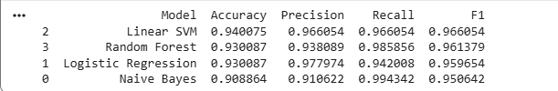

Figure 2: Model Performance Comparison Table
In our project we compared Linear SVM, Random Forest, Logistic Regression, and Native Bayes using Accuracy, Precision, Recall and F1 score, shown in Figure 2 above. Amongst the models tested Linear SVM achieved the highest overall performance with none of their scores dipping below .94. Even with Linear SVM’s impressive results the Logistic Regression model performed a comparable score of .9596 while offering greater interpretability allowing for earlier analysis of feature importance which enables us to identify key words and phrases driving the positive and negative sentiments in the Oura Ring 4 reviews. Overall Logistic Regression scores were very competitive, receiving balanced scores across the board especially in precision and recall.

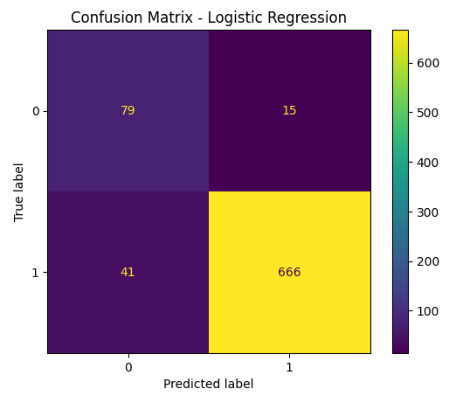
Figure 3: Confusion Matrix
We can further see this in our confusion matrix and noticed that it is slightly biased towards predicting positive sentiment which is likely due to the imbalance in the dataset where positive reviews dominate. In our confusion matrix you can see this with 15 negatives misclassified as positive and 41 positives misclassified as negative. In turn the model also correctly classified 666 positive reviews and 79 negative reviews. In all it displays how the model predicted positive sentiment really well but the bias still comes through very clearly, mainly due to the imbalance of the review levels in the dataset. This was rectified due to our use of class weights which improved the model fairness and reduced bias towards the positive predictions.
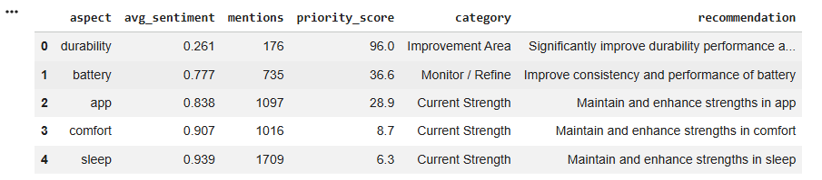

Figure 4: Oura Ring 5 Prediction Analysis

In our Prediction Analysis table we can see above in Figure 4 that while sleep was mentioned the most durability came out on top in their priority score.This is critical of revision in the new model and means that people who reviewed the Oura Ring 4 found durability of the product not up to par with what their expectations were like when given a sentiment of .26. As the customer gets closer to a sentiment value of 1 the more satisfied they are with that product's feature. Battery also comes in a close second when it comes to fixing in the new model but had a huge difference in the positive impact it left in customers with a sentiment of .77. This feature left a more mixed outcome as we can see from its medium volume and moderately high sentiment score. The next feature being the app experience shows a general positive sentiment with a score of .83 but also has a high number of mentions, meaning that it's a very important feature that should continue to be improved in the next model. Comfort and Sleep were alike in having the two highest sentiment scores of .90 and .93 with high volume as well, meaning that they were the strongest features and are most likely to come back in the next model in comparison to the rest. We can take from this model that while customers are complimenting the sleep feature some had taken notice of the wear and tear of the product based on each individual's lifestyle, which in turn may deter future customers from purchase if the issue isn't rectified in the next model.

Conclusion and Future Direction

In conclusion the findings reveal that while overall sentiment toward the product is largely positive, there are meaningful variations across product features. In particular, durability emerged as the most critical area for improvement due to its low sentiment and relatively high frequency of mentions. In contrast, features such as sleep tracking, comfort, and app experience were identified as key strengths, consistently receiving high sentiment scores and strong engagement from users. These insights provide a clear prioritization framework for guiding future product development. Some limitations that our project faced where our model may not fully capture the deeper contextual meaning within customer reviews—for example, a sarcastic review such as “Great, my ring stopped working after a week” may be incorrectly interpreted as positive. Additionally, the exclusion of neutral (three-star) reviews could limit a more comprehensive understanding of customer sentiment. Looking ahead, several opportunities exist to enhance the system. From a modeling standpoint, incorporating more advanced natural language processing techniques, such as transformer-based models, could improve the accuracy of sentiment classification by better capturing context and nuance within reviews. Additionally, including neutral (three-star) reviews rather than excluding them would provide a more complete and balanced view of customer feedback.

